**WEB TECHNOLOGY WITH UI UX**

**ASSIGNMENT 1 – TASK 1**

**NAME: JAGDISH NIKUMBH ROLLNO: 80 CLASS: 4CEB BRANCH: CE**

**Step 1 - Click on New button to create a new repository** 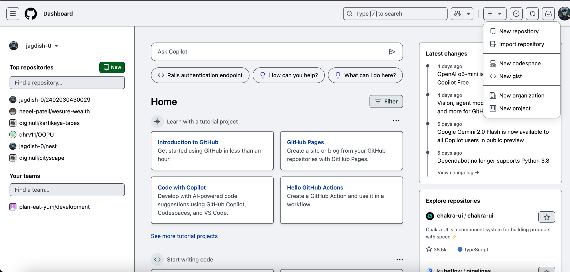

**Step 2 - In the Repository name field, enter your enrollment number**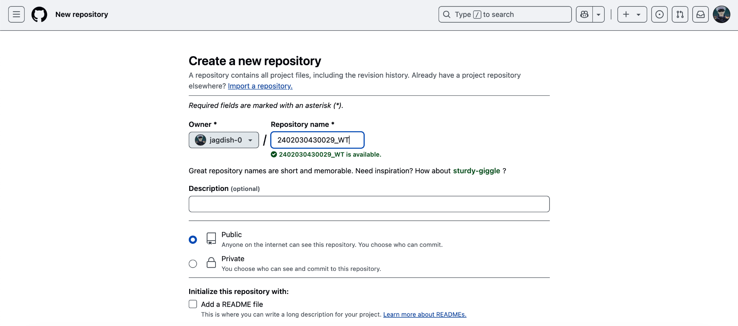

**Step 3 - Click "Create repository".**

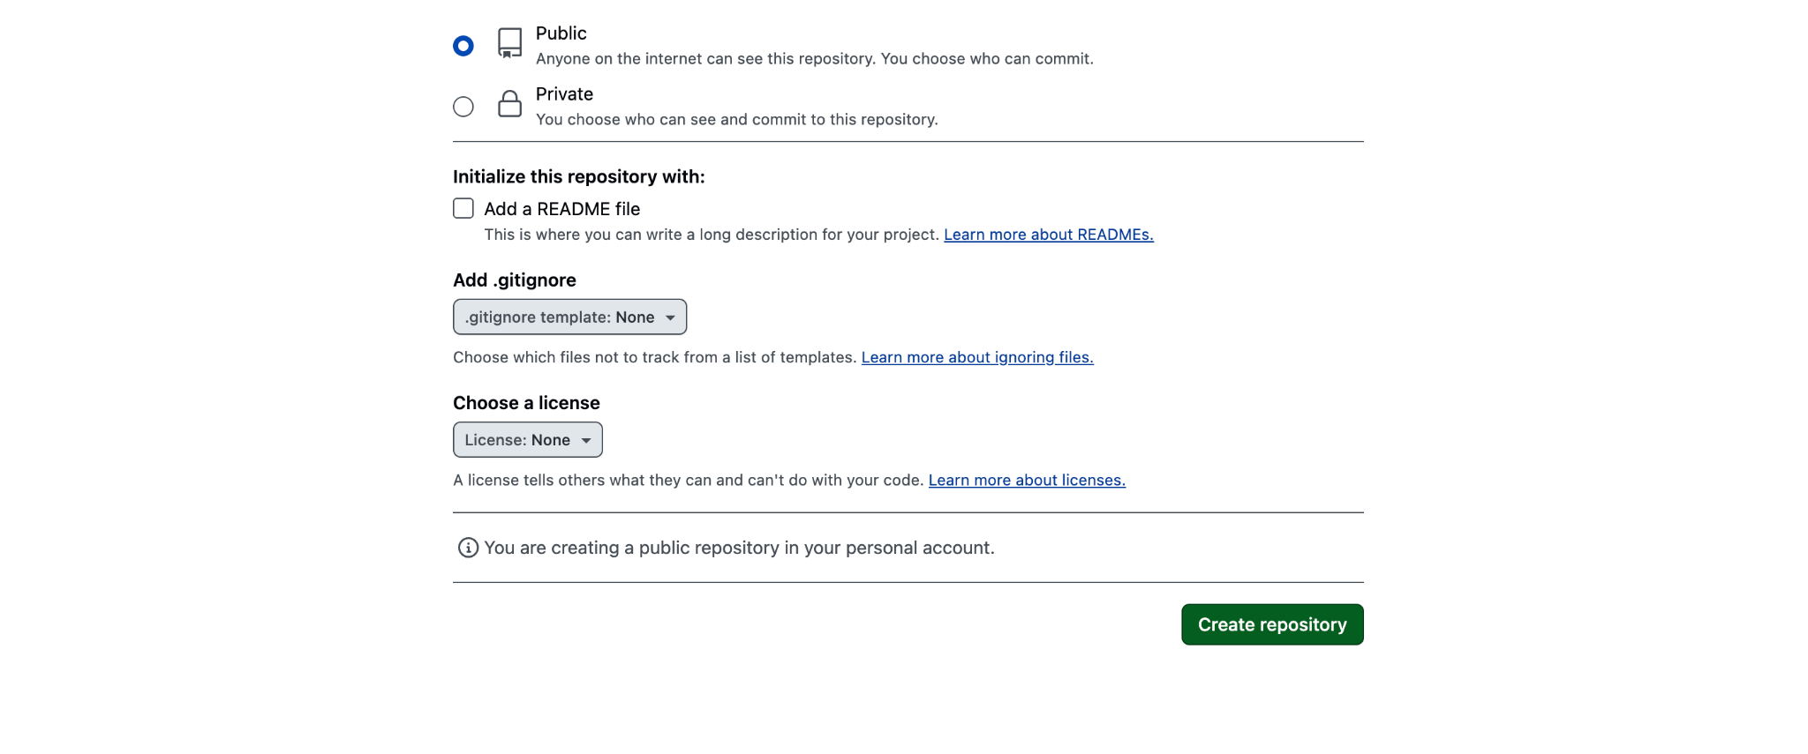

**Step 4 - Click the "Add file" dropdown, select "Create new file**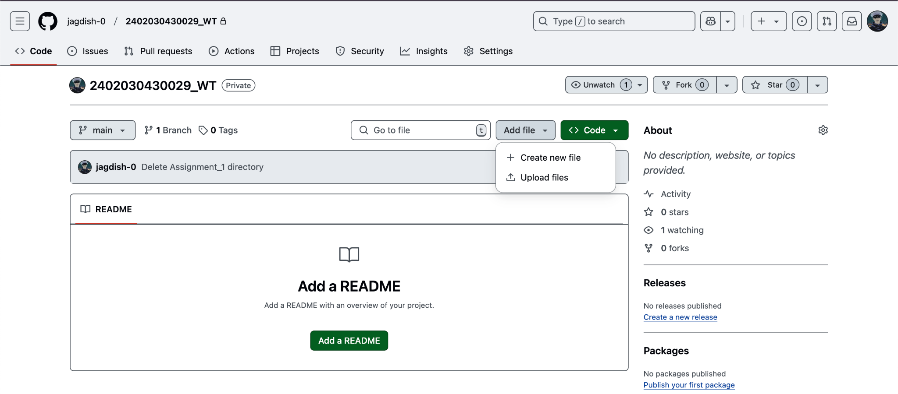

**Step 5 - Type the folder name followed by a slash (/) to create the folder structure and click on commit changes.**

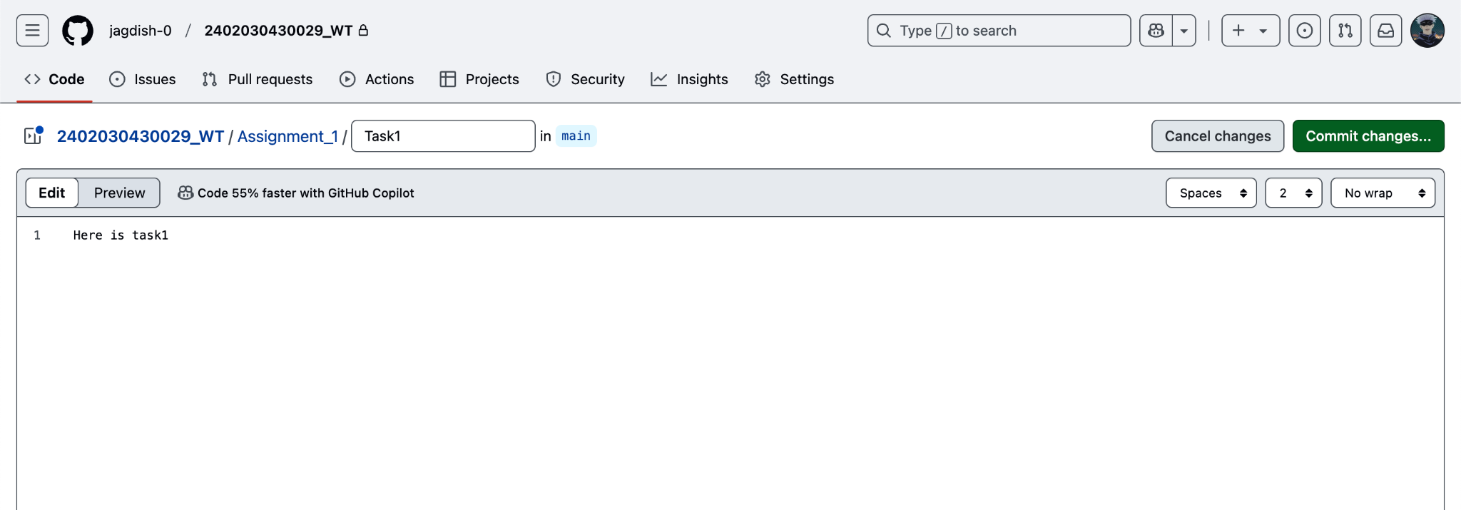

**Step 6 – Assignment 1 folder created**

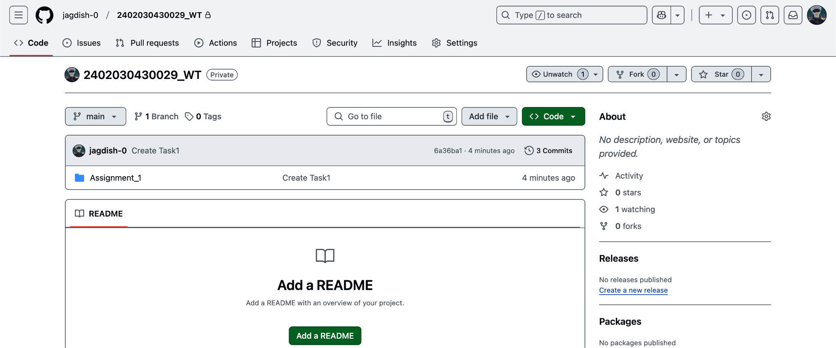

**Step 7 – Add the file into the assignment 1 folder**

